Mission 1.1

Creating and Manipulating Tables

In this activity, you will practice using the commands discussed in the mission to view and update the data in a table.



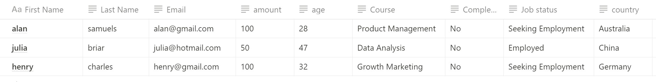

* Download the provided dataset and import it in SQLite.
* View the table and check what information is provided in it. (Clue: What are the columns of this table about?).
* We have had three new students enroll. Their data is above. Add them to the table on SQL.
* Student Kanye West, has decided to change from Product Management to Growth Marketing. Change his enrolment.
* Delete Steve Stewart’s record.
* We also want to collect data about the country and job status of our students. Add a 'country' and 'job_status' column to the table.
* When you’re finished, submit your table as a CSV file below.